(You will use your ABCISSA as a PALIMPSEST)
Using passage K2, one must dig Undergruund. Use your cipher text as a mask, your decoded message will be found directly below.
K4 WGDKZXTJCDIGKUHUAUEK = ISTNDMUDRTKONIAIRITE
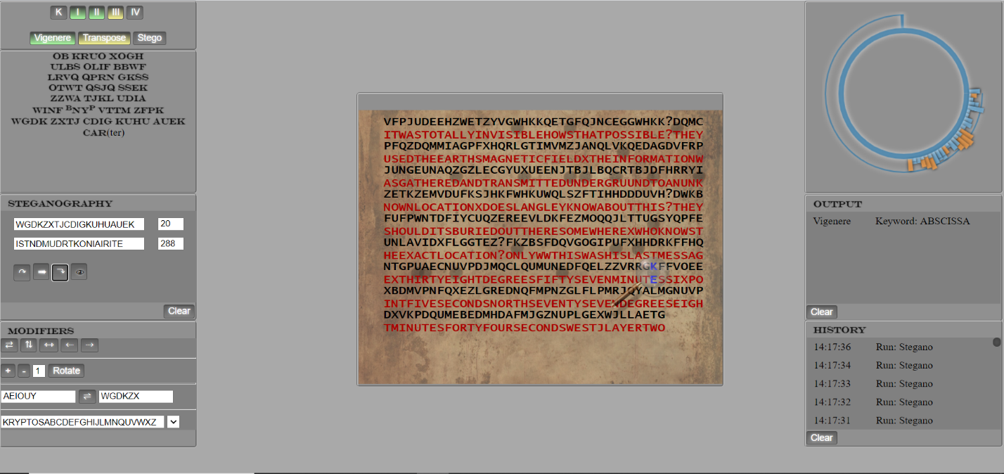

[Note] Burn marks are where there were matches. CT Above, PT below.
ISTND = could be gibberish, LST ND, I STND “ standard”, or maybe this is where the Telegram was sent.
MUD RT = Type of tire
Koni = Shocks
Airite = Truck bed shell

Later portions seem to indicate a purchase order invoice (receipt)
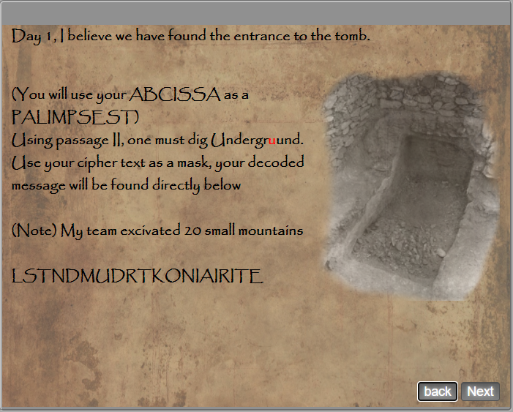

Where does the telegram fit in?
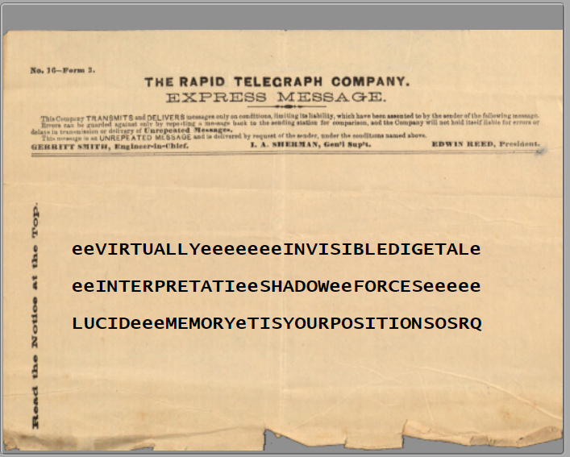
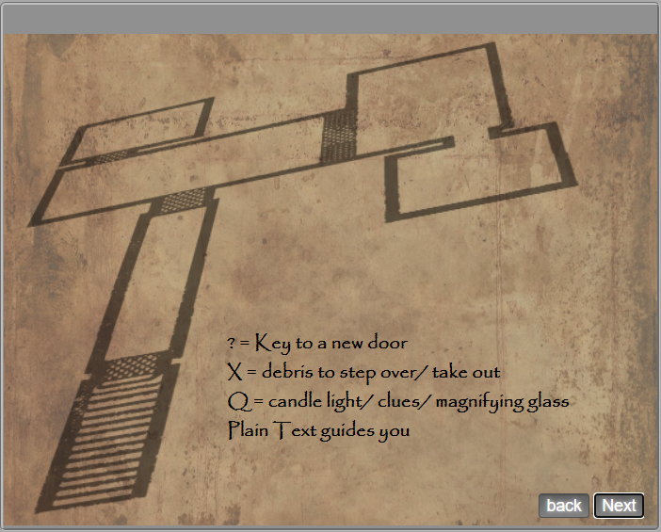
3 doors, 3 Keys “?”

